VISVESVARAYA TECHNOLOGICAL UNIVERSITY

“JnanaSangama”, Belgaum -590014, Karnataka.

LAB RECORD

Bio Inspired Systems (23CS5BSBIS)
Submitted by
Anu Sai Shree R (1BM23CS045)
in partial fulfillment for the award of the degree of

BACHELOR OF ENGINEERING
in
COMPUTER SCIENCE AND ENGINEERING



B.M.S. COLLEGE OF ENGINEERING
(Autonomous Institution under VTU)
BENGALURU-560019
Aug-2025 to Dec-2025

B.M.S. College of Engineering,
Bull Temple Road, Bangalore 560019
(Affiliated To Visvesvaraya Technological University, Belgaum)
Department of Computer Science and Engineering

CERTIFICATE
This is to certify that the Lab work entitled “ Bio Inspired Systems (23CS5BSBIS)” carried out by Anu Sai Shree R (1BM23CS045), who is bonafide student of B.M.S. College of Engineering. It is in partial fulfillment for the award of Bachelor of Engineering in Computer Science and Engineering of the Visvesvaraya Technological University, Belgaum. The Lab report has been approved as it satisfies the academic requirements of the above mentioned subject and the work prescribed for the said degree.

Dr.Namratha M  Assistant Professor  Department of CSE, BMSCE | Dr. Kavitha Sooda  Professor & HOD  Department of CSE, BMSCE

Index
Sl.  No. | Date | Experiment Title | Page No.
1 | 29/08/2025 | Genetic Algorithm for Optimization Problems | 1-8
2 | 12/09/2025 | Optimization via Gene Expression Algorithms | 9-14
3 | 10/10/2025 | Ant Colony Optimization for the Traveling Salesman Problem | 15-20
4 | 10/10/2025 | Particle Swarm Optimization for Function Optimization | 21-24
5 | 17/10/2025 | Cuckoo Search for the Traveling Salesman Problem | 25-29
6 | 24/10/2025 | Grey Wolf Optimizer for Function Optimization | 30-34
7 | 31/10/2025 | Parallel Cellular Algorithm for Function Optimization | 35-37

Github Link:

https://github.com/Anu1BM23CS045/BIS_LAB

Program 1

Problem Statement:

Genetic Algorithm for Optimization Problems:
Find the best routes for delivery vehicles with limited capacity so that all customers are served once and total travel distance is minimized using a Genetic Algorithm.

Algorithm:
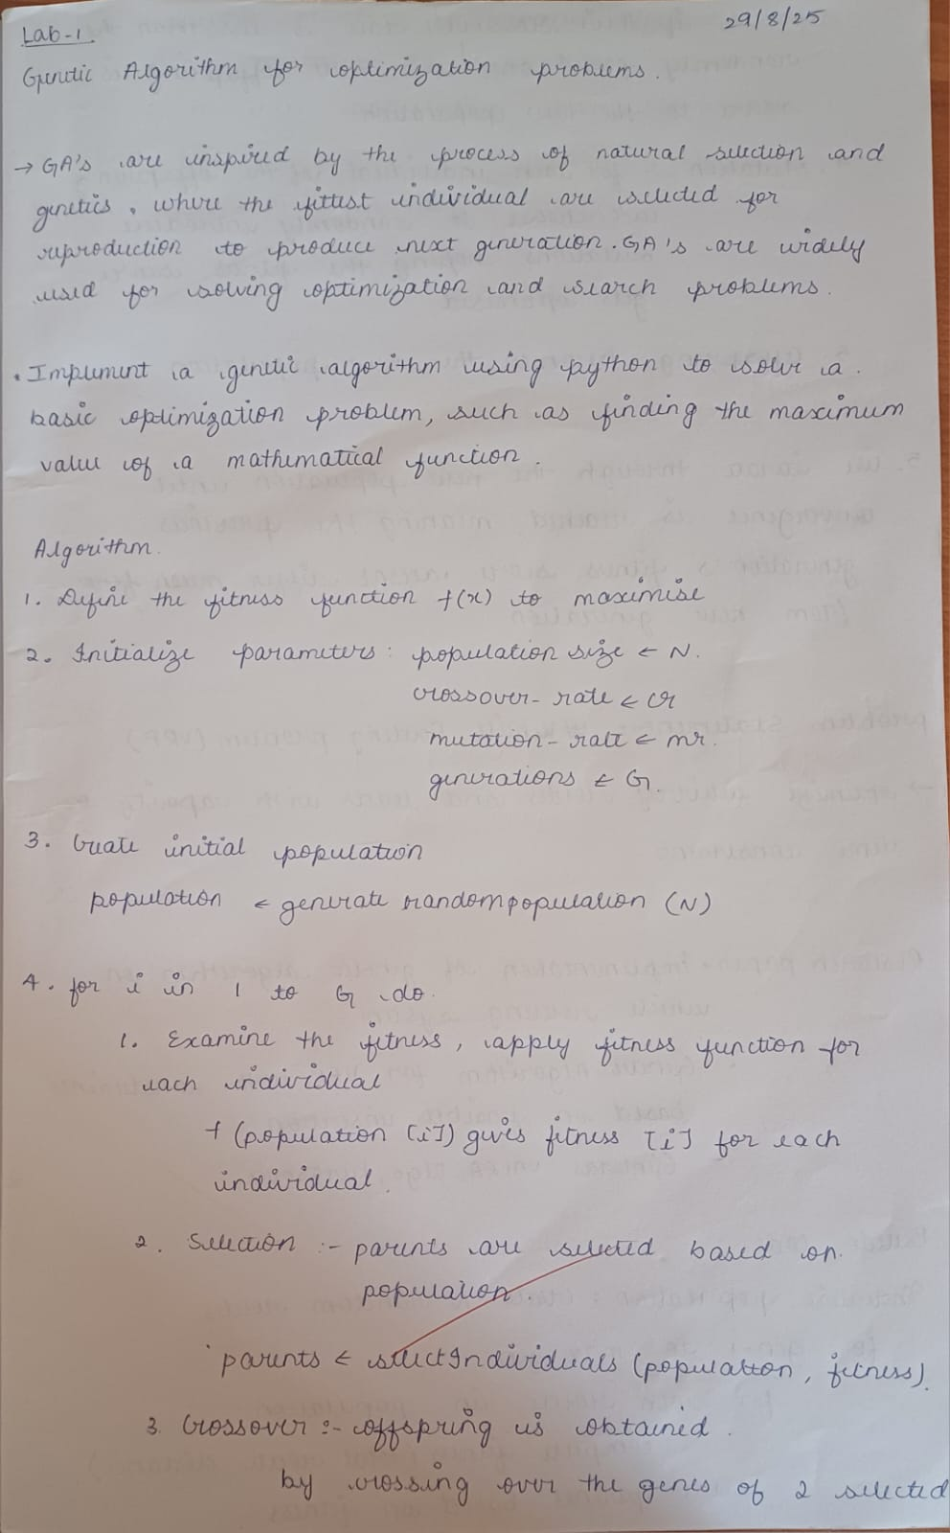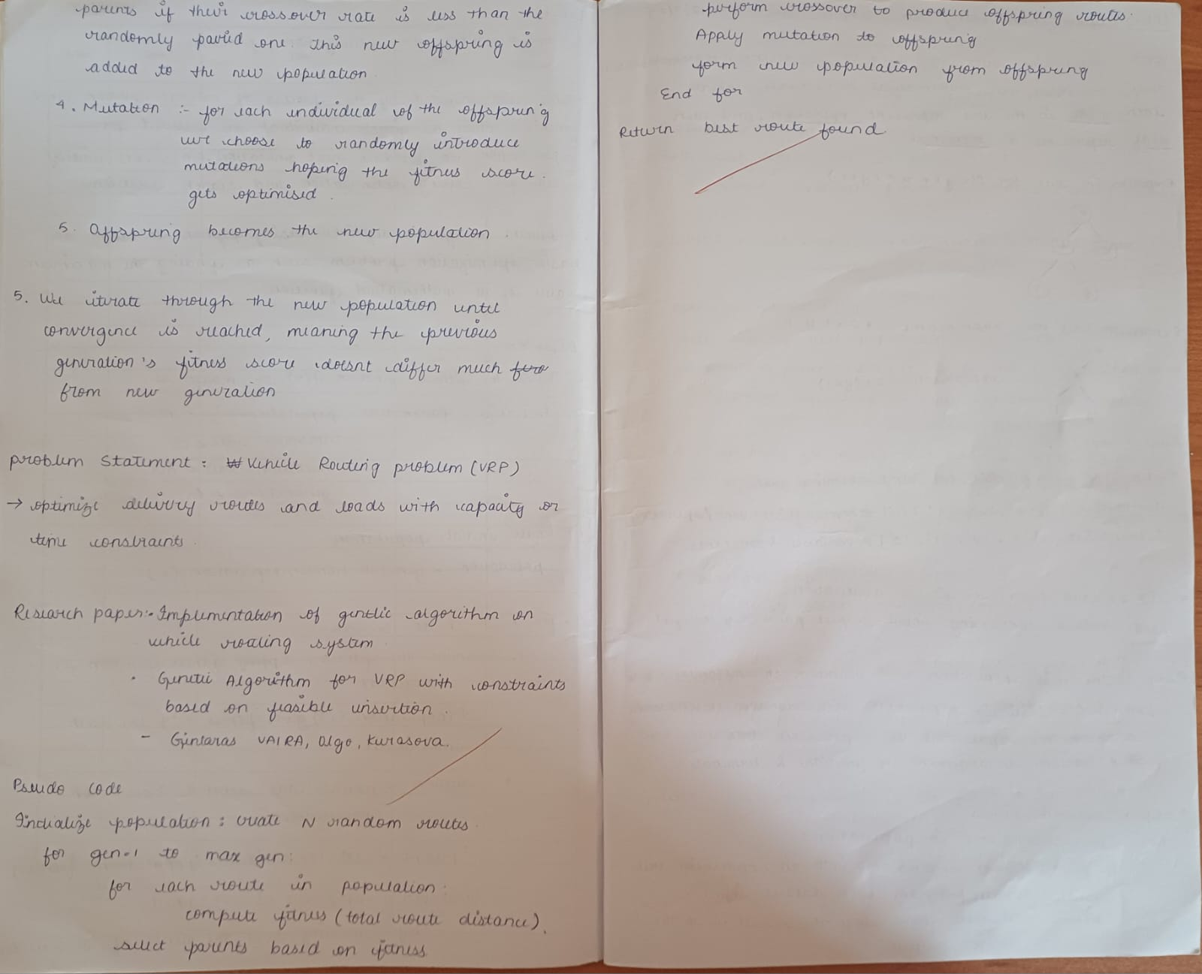

Code:

import math
import random
import copy
from typing import List, Tuple

random.seed(1)

# --------------------------
# Utility functions
# --------------------------

def euclidean(a: Tuple[float, float], b: Tuple[float, float]) -> float:
return math.hypot(a[0] - b[0], a[1] - b[1])

def compute_distance_matrix(coords: List[Tuple[float, float]]) -> List[List[float]]:
n = len(coords)
dist = [[0.0]*n for _ in range(n)]
for i in range(n):
for j in range(n):
dist[i][j] = euclidean(coords[i], coords[j])
return dist

# --------------------------
# Problem instance generator
# --------------------------

def generate_instance(num_customers=15, grid_size=100, max_demand=10, depot=(50,50)):
"""
Generates random customers with demands and coordinates.
Index 0 is the depot, customers are 1..num_customers
"""
coords = [depot]
demands = [0]
for _ in range(num_customers):
coords.append((random.uniform(0, grid_size), random.uniform(0, grid_size)))
demands.append(random.randint(1, max_demand))
return coords, demands

# --------------------------
# Chromosome -> Routes (split by capacity)
# --------------------------

def split_routes_from_perm(perm: List[int], demands: List[int], capacity: int) -> List[List[int]]:
"""
Greedy split: take customer sequence in perm, keep adding to current route
while capacity is not exceeded. Start new route when needed.
"""
routes = []
cur_route = []
cur_load = 0
for cust in perm:
d = demands[cust]
if cur_load + d <= capacity:
cur_route.append(cust)
cur_load += d
else:
# close route and start new
if cur_route:
routes.append(cur_route)
cur_route = [cust]
cur_load = d
if cur_route:
routes.append(cur_route)
return routes

def route_cost(route: List[int], dist_matrix: List[List[float]]) -> float:
if not route:
return 0.0
cost = 0.0
prev = 0 # depot
for cust in route:
cost += dist_matrix[prev][cust]
prev = cust
cost += dist_matrix[prev][0] # return to depot
return cost

def total_cost(routes: List[List[int]], dist_matrix: List[List[float]]) -> float:
return sum(route_cost(r, dist_matrix) for r in routes)

# --------------------------
# Genetic Algorithm components
# --------------------------

def init_population(pop_size: int, customer_ids: List[int]) -> List[List[int]]:
pop = []
for _ in range(pop_size):
perm = customer_ids[:]
random.shuffle(perm)
pop.append(perm)
return pop

def tournament_selection(pop: List[List[int]], fitnesses: List[float], k=3) -> List[int]:
selected = random.sample(list(range(len(pop))), k)
best = min(selected, key=lambda i: fitnesses[i])
return copy.deepcopy(pop[best])

def order_crossover(parent1: List[int], parent2: List[int]) -> Tuple[List[int], List[int]]:
"""Order Crossover (OX) for permutations."""
n = len(parent1)
a, b = sorted(random.sample(range(n), 2))
def ox(p1, p2):
child = [None]*n
# copy slice
child[a:b+1] = p1[a:b+1]
# fill remaining from p2 order
pos = (b+1) % n
p2_i = (b+1) % n
while None in child:
val = p2[p2_i]
if val not in child:
child[pos] = val
pos = (pos+1) % n
p2_i = (p2_i+1) % n
return child
return ox(parent1, parent2), ox(parent2, parent1)

def swap_mutation(perm: List[int], mut_rate=0.2) -> None:
"""In-place swap mutation (may perform multiple swaps based on mut_rate)."""
n = len(perm)
for i in range(n):
if random.random() < mut_rate:
j = random.randrange(n)
perm[i], perm[j] = perm[j], perm[i]

# --------------------------
# GA main loop
# --------------------------

def evaluate_population(pop: List[List[int]], demands: List[int], capacity: int, dist_matrix: List[List[float]]):
fitnesses = []
for indiv in pop:
routes = split_routes_from_perm(indiv, demands, capacity)
fitnesses.append(total_cost(routes, dist_matrix))
return fitnesses

def ga_vrp(
coords: List[Tuple[float, float]],
demands: List[int],
capacity: int,
pop_size=100,
gens=300,
crossover_rate=0.8,
mutation_rate=0.15,
elitism=2
):
n = len(coords) - 1 # number of customers
customer_ids = list(range(1, n+1))
dist_matrix = compute_distance_matrix(coords)

pop = init_population(pop_size, customer_ids)
fitnesses = evaluate_population(pop, demands, capacity, dist_matrix)

best_history = []
for gen in range(gens):
new_pop = []
# Elitism: keep best individuals
sorted_idx = sorted(range(len(pop)), key=lambda i: fitnesses[i])
for i in range(elitism):
new_pop.append(copy.deepcopy(pop[sorted_idx[i]]))

while len(new_pop) < pop_size:
# Selection
p1 = tournament_selection(pop, fitnesses, k=3)
p2 = tournament_selection(pop, fitnesses, k=3)
# Crossover
if random.random() < crossover_rate:
c1, c2 = order_crossover(p1, p2)
else:
c1, c2 = p1, p2
# Mutation
swap_mutation(c1, mutation_rate)
swap_mutation(c2, mutation_rate)
new_pop.append(c1)
if len(new_pop) < pop_size:
new_pop.append(c2)

pop = new_pop
fitnesses = evaluate_population(pop, demands, capacity, dist_matrix)
gen_best = min(fitnesses)
best_history.append(gen_best)

if (gen+1) % (max(1, gens//10)) == 0 or gen == 0:
print(f"Gen {gen+1:4d} | best cost = {gen_best:.2f}")

# final best
best_idx = min(range(len(pop)), key=lambda i: fitnesses[i])
best_perm = pop[best_idx]
best_routes = split_routes_from_perm(best_perm, demands, capacity)
best_cost = fitnesses[best_idx]
return {
'best_perm': best_perm,
'best_routes': best_routes,
'best_cost': best_cost,
'dist_matrix': dist_matrix,
'history': best_history
}

# --------------------------
# Example / Run
# --------------------------

if __name__ == "__main__":
# Example instance
NUM_CUSTOMERS = 12
VEHICLE_CAPACITY = 30
coords, demands = generate_instance(num_customers=NUM_CUSTOMERS, grid_size=100, max_demand=12, depot=(50,50))

print("Depot coords:", coords[0])
for i in range(1, len(coords)):
print(f"Customer {i:2d} at {coords[i]} demand={demands[i]}")

result = ga_vrp(
coords=coords,
demands=demands,
capacity=VEHICLE_CAPACITY,
pop_size=120,
gens=300,
crossover_rate=0.9,
mutation_rate=0.12,
elitism=4
)

print("\n=== BEST SOLUTION ===")
print(f"Total cost: {result['best_cost']:.2f}")
print("Routes (customers listed, depot implicit at start/end):")
for idx, r in enumerate(result['best_routes'], start=1):
load = sum(demands[c] for c in r)
rcost = route_cost(r, result['dist_matrix'])
print(f" Vehicle {idx}: {r} | load={load} | route_cost={rcost:.2f}")
print("\nBest permutation (customer visit order):", result['best_perm'])

Output:
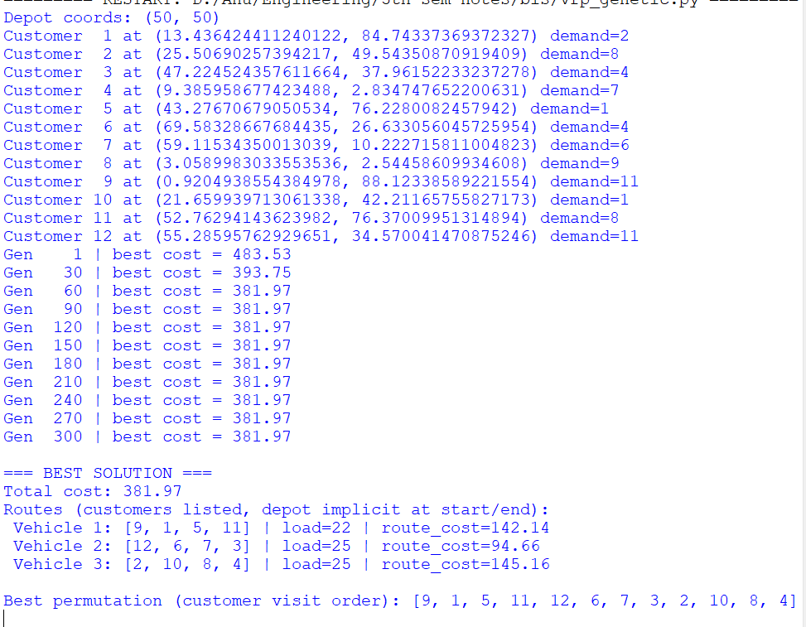

Program 2

Problem Statement:

Optimization via Gene Expression Algorithms:
Use Gene Expression Programming to find the best mathematical expression or variable values that optimize a given function.

Algorithm:
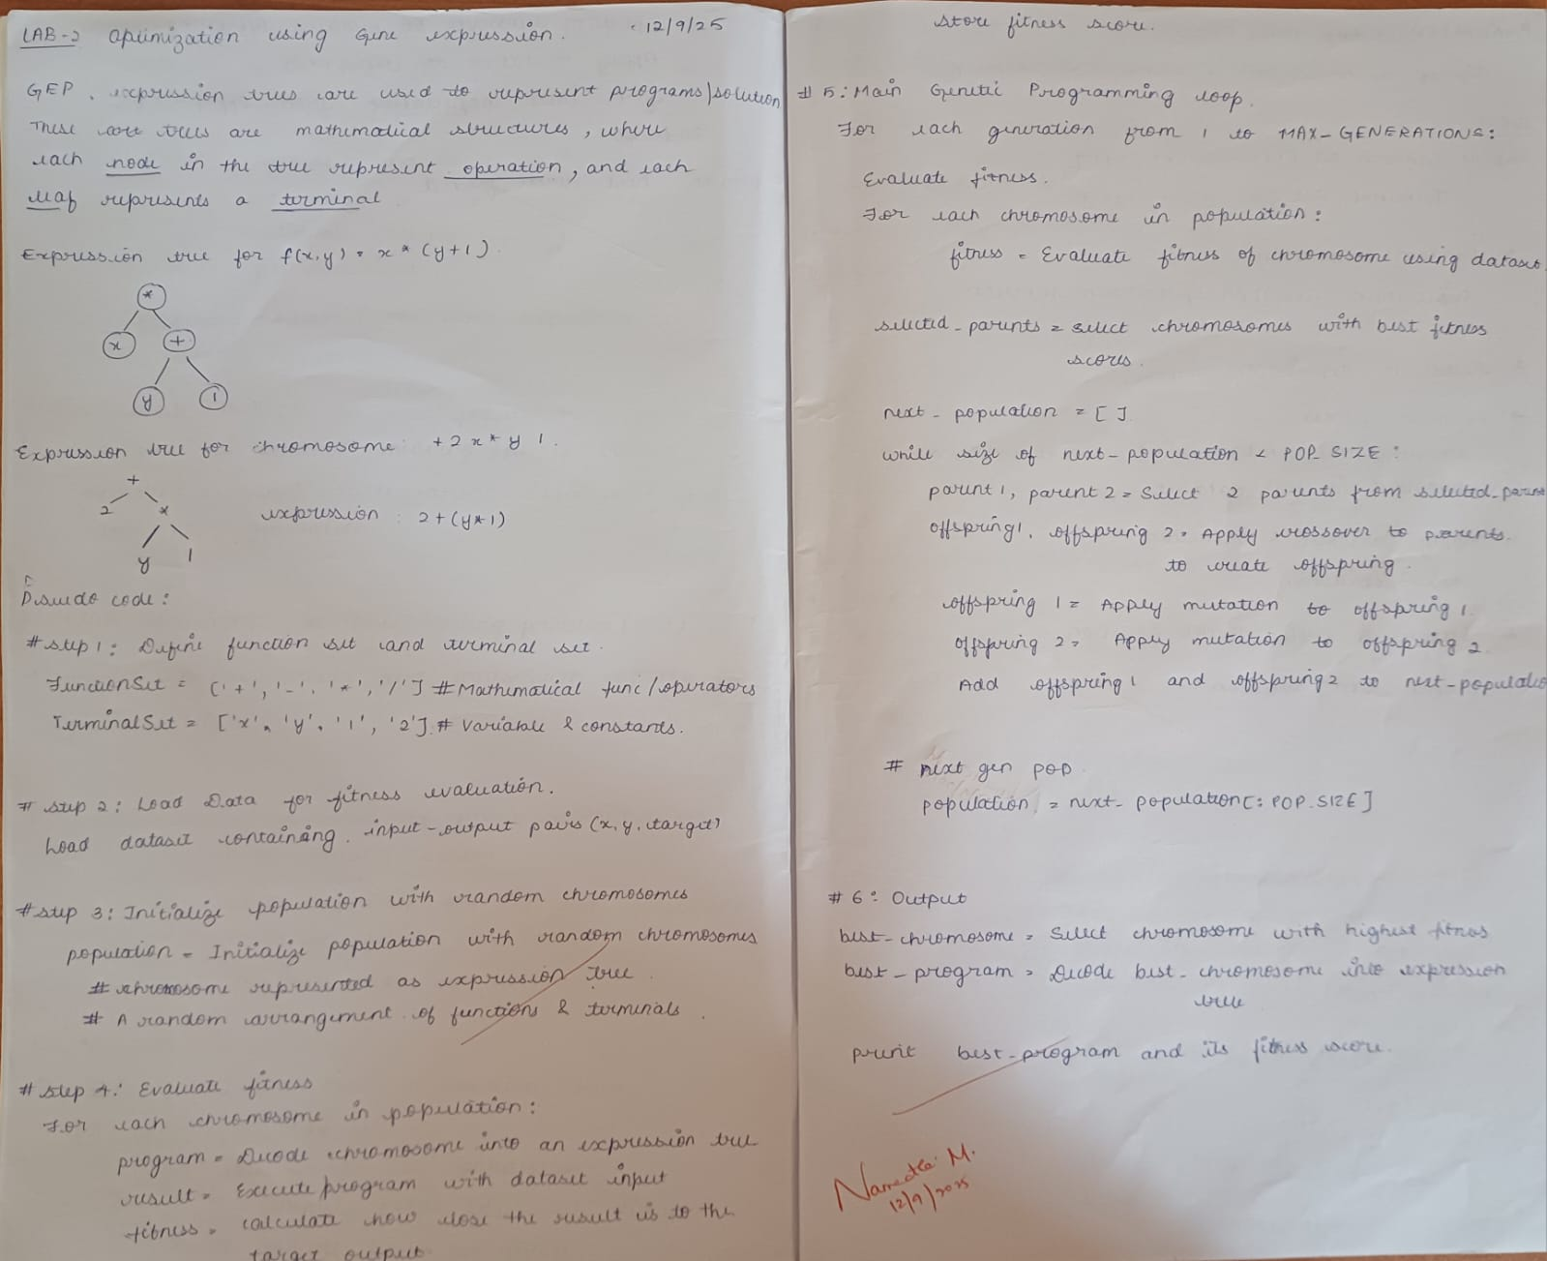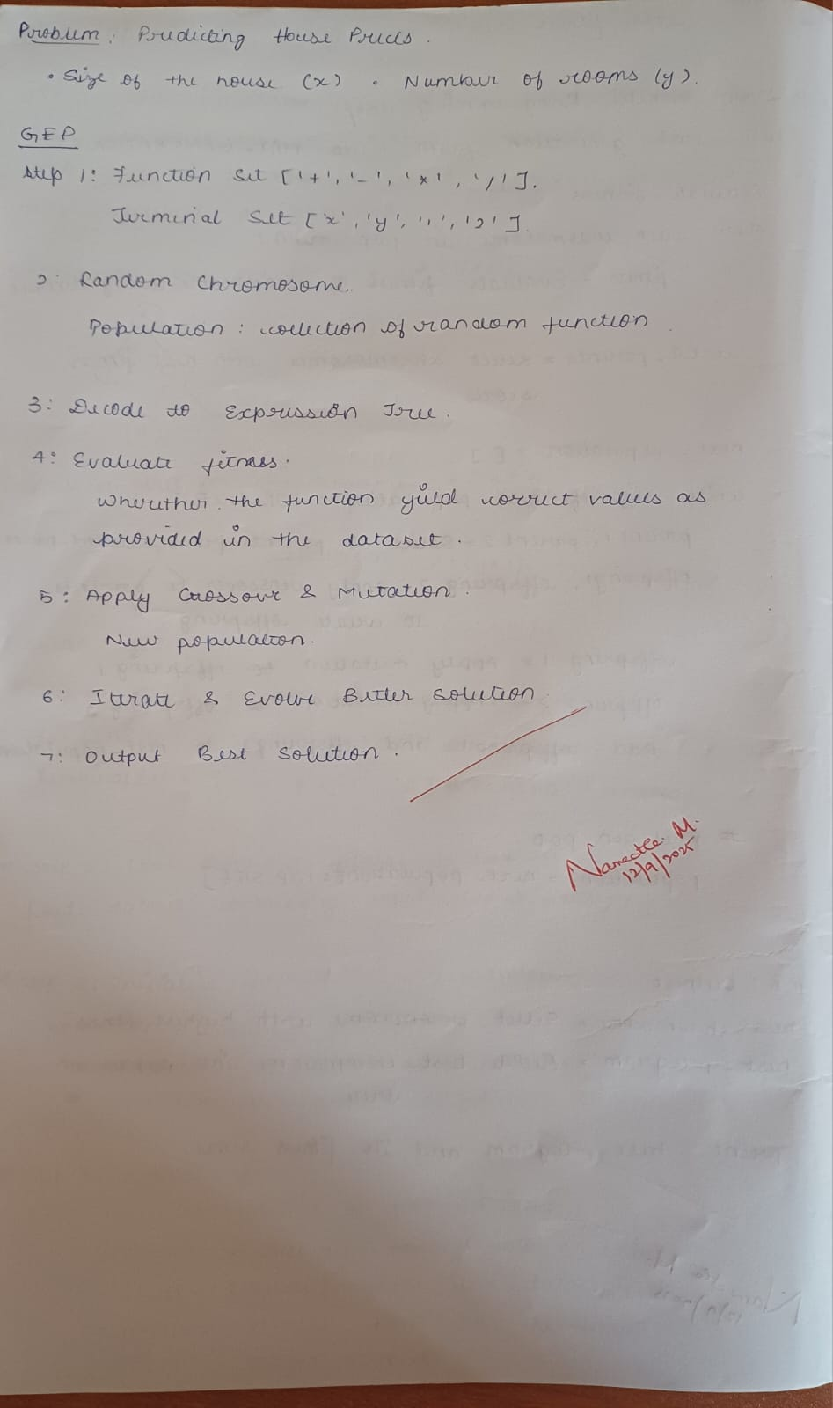

Code:
import random
import math

# Target function to approximate
def target_function(x):
return x**2 + x + 1

# Terminal and function sets
TERMINALS = ['x']
FUNCTIONS = ['+', '-', '*', '/']

# Parameters
POP_SIZE = 100
MUTATION_RATE = 0.1
TOURNAMENT_SIZE = 3
GENERATIONS = 100

# ---------------------
# Utility functions
# ---------------------

def safe_div(a, b):
"""Safe division to avoid divide-by-zero."""
try:
return a / b if b != 0 else 1
except:
return 1

def random_gene(max_depth=3):
"""Randomly create an expression (gene) of limited depth."""
if max_depth == 0 or (max_depth > 1 and random.random() < 0.3):
return random.choice(TERMINALS)
else:
op = random.choice(FUNCTIONS)
left = random_gene(max_depth - 1)
right = random_gene(max_depth - 1)
return f"({left}{op}{right})"

def evaluate_expression(expr, x):
"""Safely evaluate the evolved expression."""
try:
# Define the environment so eval can use math and safe_div properly
env = {"x": x, "math": math, "safe_div": safe_div}
# Replace '/' with safe_div(a,b)
expr_safe = expr.replace("/", "safe_div")
result = eval(expr_safe, env)
if callable(result): # in case a function is accidentally returned
return 0
return float(result)
except Exception:
return 0

def fitness(expr):
"""Mean squared error against target function."""
xs = [i for i in range(-10, 11)]
errors = []
for x in xs:
y_true = target_function(x)
y_pred = evaluate_expression(expr, x)
errors.append((y_true - y_pred)**2)
mse = sum(errors) / len(errors)
return mse

# ---------------------
# Genetic operators
# ---------------------

def mutate(expr):
"""Randomly mutate part of the expression."""
expr_list = list(expr)
for i in range(len(expr_list)):
if random.random() < MUTATION_RATE:
expr_list[i] = random.choice(['x', '+', '-', '*', '/'])
return ''.join(expr_list)

def crossover(parent1, parent2):
"""Single-point crossover."""
if len(parent1) < 2 or len(parent2) < 2:
return parent1, parent2
cut1 = random.randint(1, len(parent1) - 1)
cut2 = random.randint(1, len(parent2) - 1)
child1 = parent1[:cut1] + parent2[cut2:]
child2 = parent2[:cut2] + parent1[cut1:]
return child1, child2

def tournament_selection(pop, fits):
"""Select the best of k random individuals."""
chosen = random.sample(list(zip(pop, fits)), TOURNAMENT_SIZE)
return min(chosen, key=lambda x: x[1])[0]

# ---------------------
# Main GEP loop
# ---------------------

def gene_expression_optimization():
population = [random_gene() for _ in range(POP_SIZE)]

for gen in range(GENERATIONS):
fitnesses = [fitness(expr) for expr in population]
best_idx = min(range(len(fitnesses)), key=lambda i: fitnesses[i])
best_expr = population[best_idx]
best_fit = fitnesses[best_idx]

if gen % 10 == 0 or gen == GENERATIONS - 1:
print(f"Generation {gen:3d} | Best Expr: {best_expr} | Fitness = {best_fit:.6f}")

new_pop = [best_expr] # elitism
while len(new_pop) < POP_SIZE:
p1 = tournament_selection(population, fitnesses)
p2 = tournament_selection(population, fitnesses)
c1, c2 = crossover(p1, p2)
new_pop.extend([mutate(c1), mutate(c2)])
population = new_pop[:POP_SIZE]

print("\n✅ Optimization Complete!")
print(f"Best evolved expression: {best_expr}")
return best_expr

# ---------------------
# Run
# ---------------------
if __name__ == "__main__":
best = gene_expression_optimization()

print("\nSample comparison:")
for x in [-3, 0, 2, 5]:
print(f"x={x:>2} | Target={target_function(x):>8.3f} | Evolved={evaluate_expression(best, x):>8.3f}")

Output:
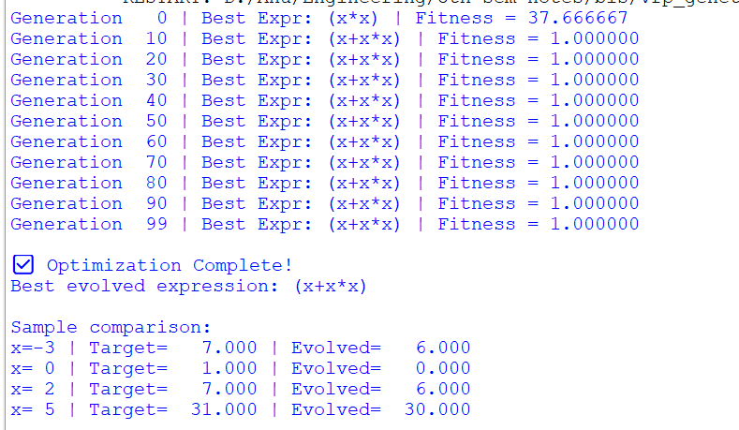

Program 3

Problem Statement:

Ant Colony Optimization for the Traveling Salesman Problem:
Use Ant Colony Optimization to find the shortest possible route that visits all cities exactly once and returns to the starting city.

Algorithm:
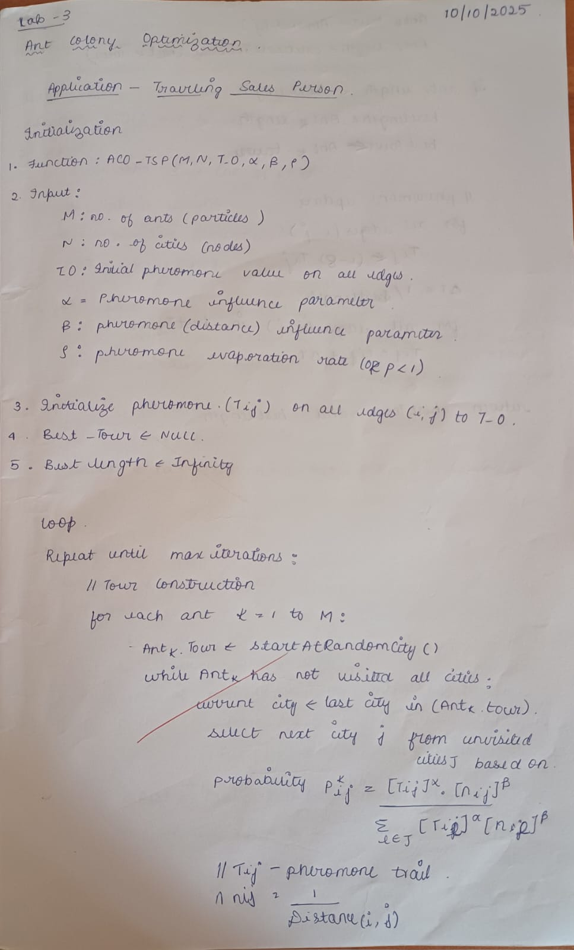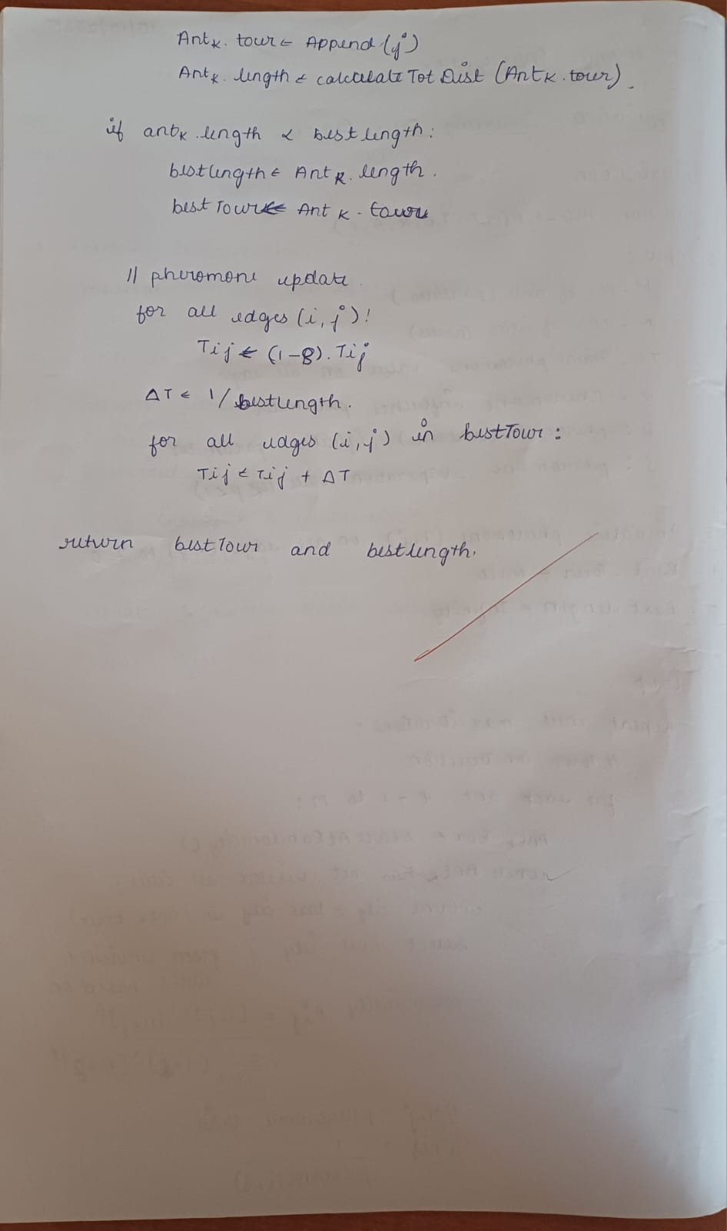

Code:
import random
import math

# -----------------------------
# PARAMETERS
# -----------------------------
NUM_CITIES = 10
NUM_ANTS = 20
ALPHA = 1.0 # pheromone importance
BETA = 5.0 # distance importance
RHO = 0.5 # evaporation rate
Q = 100 # pheromone deposit factor
ITERATIONS = 100

random.seed(1)

# -----------------------------
# CREATE TSP INSTANCE
# -----------------------------
def generate_cities(n, grid_size=100):
"""Randomly generate city coordinates."""
return [(random.uniform(0, grid_size), random.uniform(0, grid_size)) for _ in range(n)]

def distance(a, b):
return math.hypot(a[0] - b[0], a[1] - b[1])

def compute_distance_matrix(cities):
n = len(cities)
dist = [[0]*n for _ in range(n)]
for i in range(n):
for j in range(n):
if i != j:
dist[i][j] = distance(cities[i], cities[j])
return dist

# -----------------------------
# ACO Core
# -----------------------------
def initialize_pheromones(n):
"""Initialize pheromone levels between cities."""
return [[1.0 for _ in range(n)] for _ in range(n)]

def select_next_city(probabilities):
"""Roulette-wheel selection."""
r = random.random()
cumulative = 0.0
for i, p in enumerate(probabilities):
cumulative += p
if r <= cumulative:
return i
return len(probabilities) - 1

def ant_tour(dist_matrix, pheromone):
"""Construct a complete tour for one ant."""
n = len(dist_matrix)
unvisited = list(range(n))
start = random.choice(unvisited)
tour = [start]
unvisited.remove(start)

while unvisited:
current = tour[-1]
probs = []
denom = 0.0
for j in unvisited:
denom += (pheromone[current][j] ** ALPHA) * ((1.0 / dist_matrix[current][j]) ** BETA)
for j in unvisited:
num = (pheromone[current][j] ** ALPHA) * ((1.0 / dist_matrix[current][j]) ** BETA)
probs.append(num / denom if denom > 0 else 0)
next_city = unvisited[select_next_city(probs)]
tour.append(next_city)
unvisited.remove(next_city)
return tour

def tour_length(tour, dist_matrix):
"""Calculate total length of the tour."""
total = 0.0
for i in range(len(tour) - 1):
total += dist_matrix[tour[i]][tour[i+1]]
total += dist_matrix[tour[-1]][tour[0]] # return to start
return total

def update_pheromones(pheromone, all_tours, all_lengths):
"""Evaporate and deposit pheromones based on ant tours."""
n = len(pheromone)
# Evaporation
for i in range(n):
for j in range(n):
pheromone[i][j] *= (1 - RHO)
if pheromone[i][j] < 1e-6:
pheromone[i][j] = 1e-6

# Deposit pheromones
for tour, L in zip(all_tours, all_lengths):
deposit = Q / L
for i in range(len(tour) - 1):
a, b = tour[i], tour[i+1]
pheromone[a][b] += deposit
pheromone[b][a] += deposit
# return edge
pheromone[tour[-1]][tour[0]] += deposit
pheromone[tour[0]][tour[-1]] += deposit

# -----------------------------
# ACO MAIN LOOP
# -----------------------------
def aco_tsp(num_cities=NUM_CITIES):
cities = generate_cities(num_cities)
dist_matrix = compute_distance_matrix(cities)
pheromone = initialize_pheromones(num_cities)

best_tour = None
best_length = float('inf')

for it in range(ITERATIONS):
all_tours = []
all_lengths = []

for ant in range(NUM_ANTS):
tour = ant_tour(dist_matrix, pheromone)
L = tour_length(tour, dist_matrix)
all_tours.append(tour)
all_lengths.append(L)

if L < best_length:
best_length = L
best_tour = tour

update_pheromones(pheromone, all_tours, all_lengths)

if (it + 1) % 10 == 0 or it == 0:
print(f"Iteration {it+1:3d} | Best Length: {best_length:.2f}")

print("\n✅ Optimization Complete!")
print(f"Best Tour Length: {best_length:.2f}")
print(f"Best Tour: {best_tour}")
return best_tour, best_length, cities

# -----------------------------
# RUN
# -----------------------------
if __name__ == "__main__":
best_tour, best_length, cities = aco_tsp()

Output:
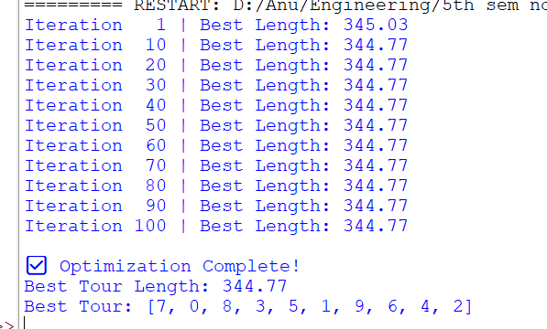

Program 4

Problem Statement:

Particle Swarm Optimization for Function Optimization:
Apply Particle Swarm Optimization to find the optimal solution (minimum or maximum) of a given mathematical function.

Algorithm:
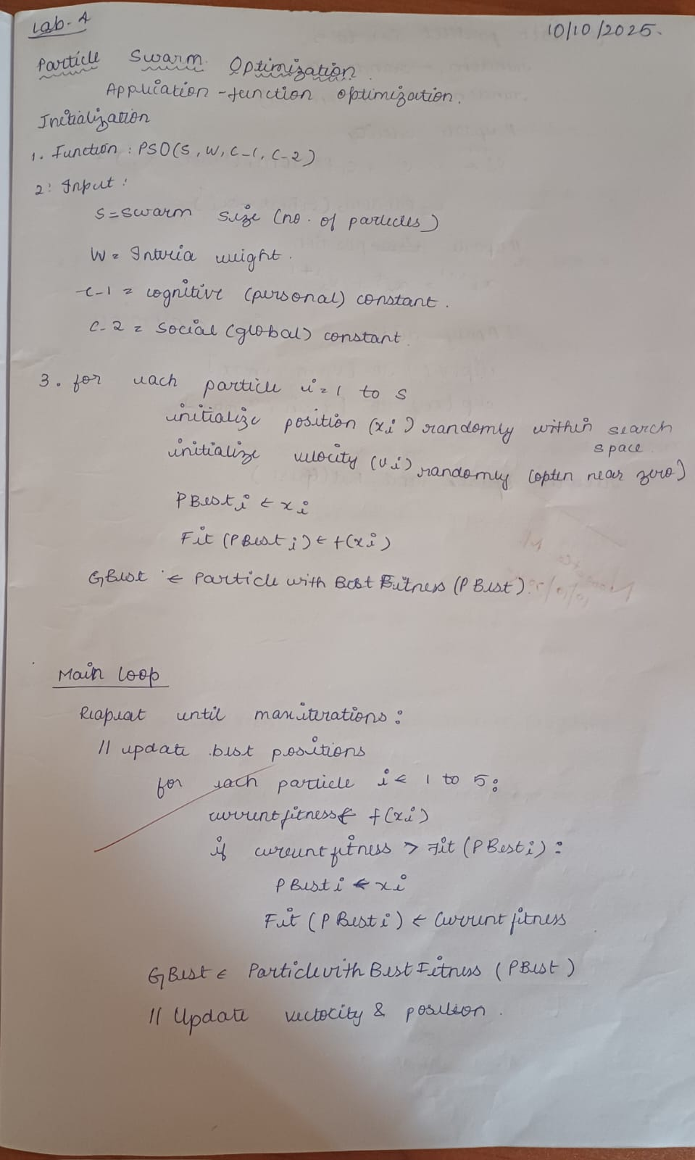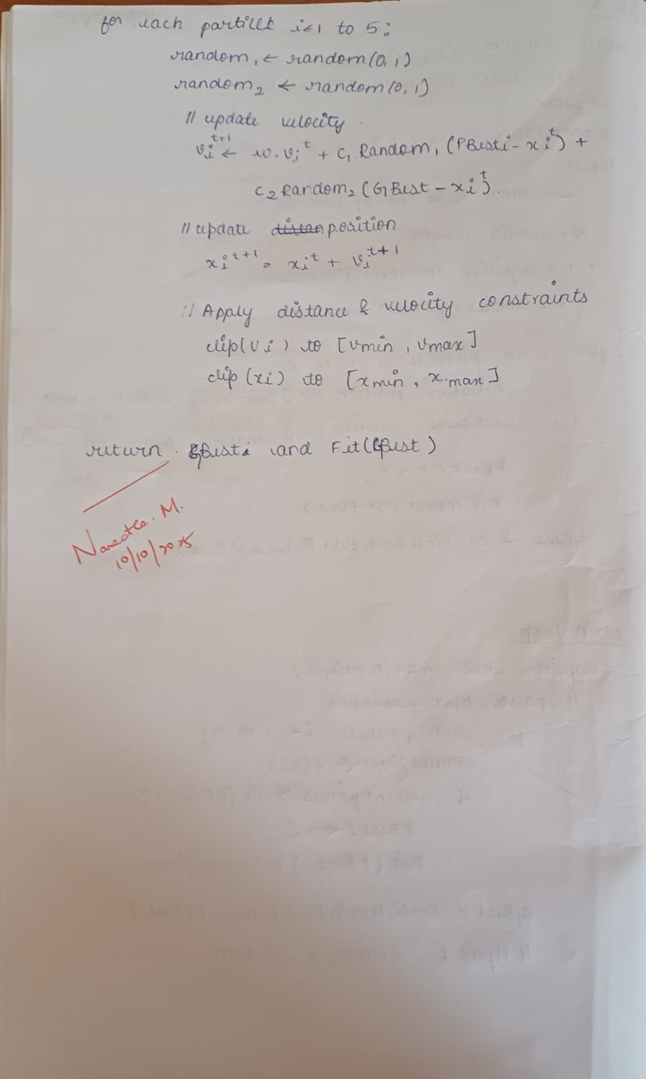

Code:
import random
import math

# Define the mathematical function to optimize (minimize)
def objective_function(x, y):
return x**2 + y**2 # Sphere function

# PSO parameters
num_particles = 30
max_iterations = 100
w = 0.7 # inertia weight
c1 = 1.5 # cognitive (particle) weight
c2 = 1.5 # social (swarm) weight

# Initialize particles
particles = []
for i in range(num_particles):
x = random.uniform(-10, 10)
y = random.uniform(-10, 10)
velocity = [random.uniform(-1, 1), random.uniform(-1, 1)]
fitness = objective_function(x, y)
particles.append({
"position": [x, y],
"velocity": velocity,
"best_pos": [x, y],
"best_fit": fitness
})

# Initialize global best
global_best = min(particles, key=lambda p: p["best_fit"])
global_best_pos = global_best["best_pos"]
global_best_fit = global_best["best_fit"]

# Main PSO loop
for t in range(max_iterations):
for particle in particles:
# Update velocity
r1, r2 = random.random(), random.random()
for i in range(2):
cognitive = c1 * r1 * (particle["best_pos"][i] - particle["position"][i])
social = c2 * r2 * (global_best_pos[i] - particle["position"][i])
particle["velocity"][i] = w * particle["velocity"][i] + cognitive + social

# Update position
particle["position"][0] += particle["velocity"][0]
particle["position"][1] += particle["velocity"][1]

# Evaluate new fitness
fit = objective_function(particle["position"][0], particle["position"][1])

# Update personal best
if fit < particle["best_fit"]:
particle["best_fit"] = fit
particle["best_pos"] = particle["position"][:]

# Update global best
if fit < global_best_fit:
global_best_fit = fit
global_best_pos = particle["position"][:]

print(f"Iteration {t+1}/{max_iterations} - Best Fitness: {global_best_fit:.6f}")

print("\n✅ Optimization complete!")
print(f"Best position found: {global_best_pos}")
print(f"Minimum value of function: {global_best_fit:.6f}")

Output:
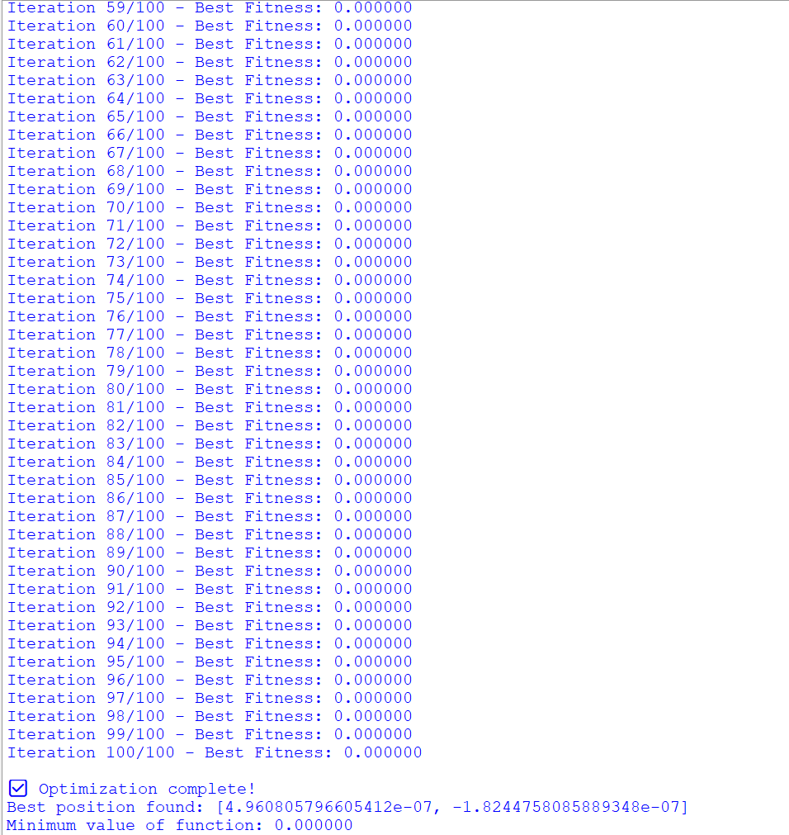

Program 5

Problem Statement:

Cuckoo Search (CS) for travel salesman problem :
Use the Cuckoo Search Algorithm to determine the shortest route for a salesman to visit all cities and return to the starting point.

Algorithm:
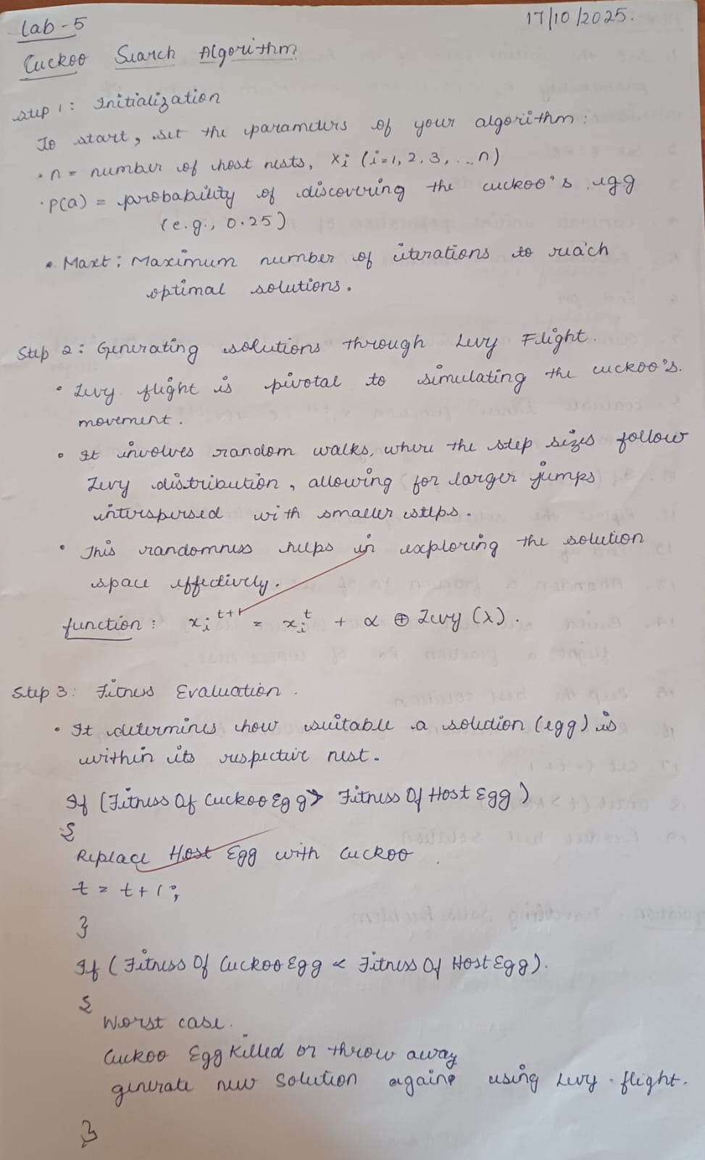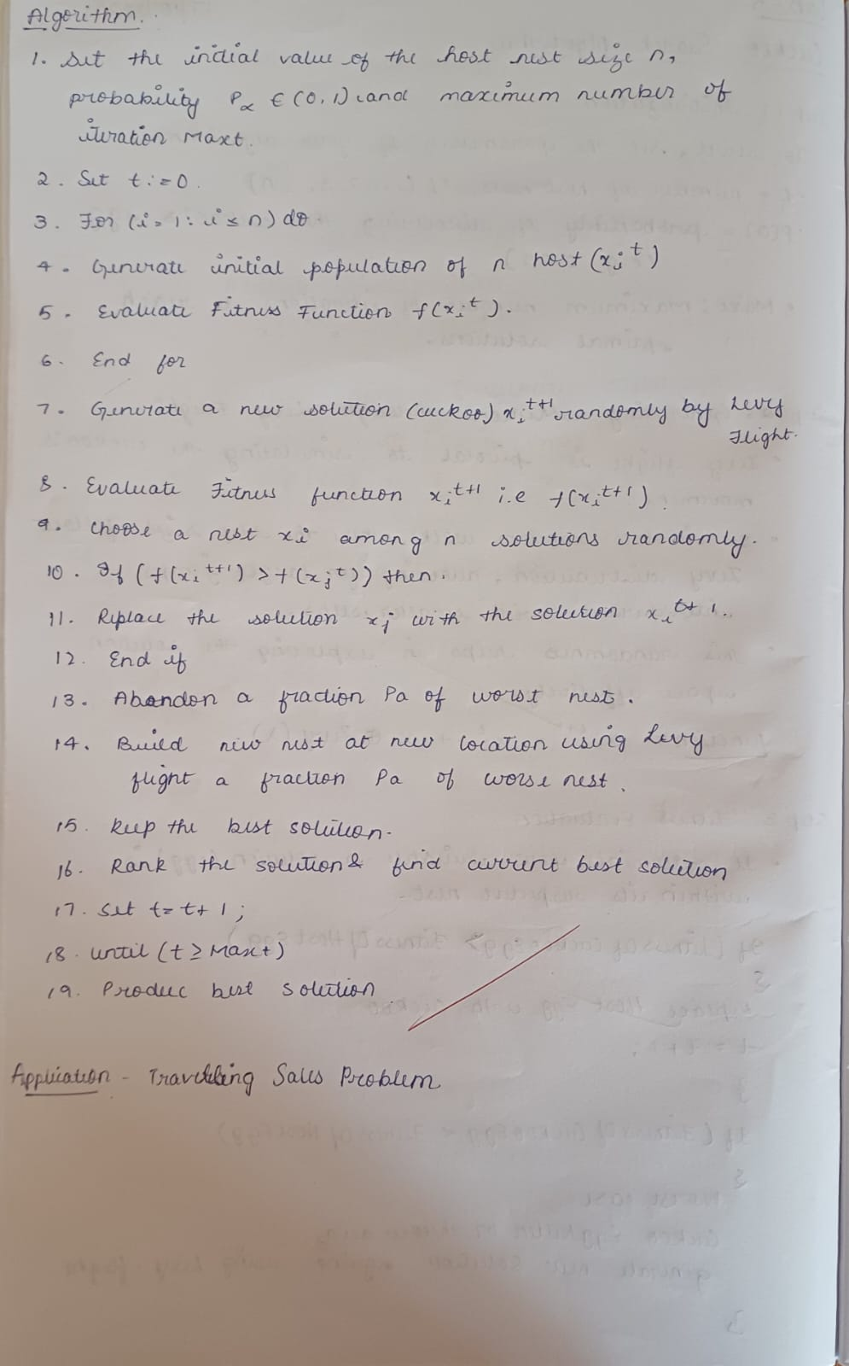

Code:
import random
import math

# -------------------------------
# Helper functions
# -------------------------------

def distance(city1, city2):
"""Euclidean distance between two cities"""
return math.sqrt((city1[0] - city2[0])**2 + (city1[1] - city2[1])**2)

def total_distance(path, cities):
"""Compute total distance of the path"""
dist = 0
for i in range(len(path)):
city1 = cities[path[i]]
city2 = cities[path[(i + 1) % len(path)]]
dist += distance(city1, city2)
return dist

def levy_flight(Lambda):
"""Generate step size using Lévy distribution"""
sigma = (math.gamma(1 + Lambda) * math.sin(math.pi * Lambda / 2) /
(math.gamma((1 + Lambda) / 2) * Lambda * 2**((Lambda - 1) / 2)))**(1 / Lambda)
u = random.gauss(0, sigma)
v = random.gauss(0, 1)
step = u / abs(v)**(1 / Lambda)
return step

def get_new_solution(path):
"""Generate a new random permutation by swapping two cities"""
new_path = path[:]
i, j = random.sample(range(len(new_path)), 2)
new_path[i], new_path[j] = new_path[j], new_path[i]
return new_path

# -------------------------------
# Cuckoo Search Algorithm
# -------------------------------

def cuckoo_search_tsp(cities, n_nests=15, pa=0.25, alpha=1, Lambda=1.5, max_iter=100):
# Initialize nests (random permutations)
nests = [random.sample(range(len(cities)), len(cities)) for _ in range(n_nests)]
fitness = [total_distance(nest, cities) for nest in nests]

best_nest = nests[fitness.index(min(fitness))]
best_fitness = min(fitness)

for iteration in range(max_iter):
for i in range(n_nests):
# Lévy flight (small random move)
step_size = levy_flight(Lambda)
new_nest = get_new_solution(nests[i])

new_fitness = total_distance(new_nest, cities)

# If better, replace
if new_fitness < fitness[i]:
nests[i] = new_nest
fitness[i] = new_fitness

# Update best
if new_fitness < best_fitness:
best_nest = new_nest[:]
best_fitness = new_fitness

# Abandon some nests with probability pa
for i in range(n_nests):
if random.random() < pa:
nests[i] = random.sample(range(len(cities)), len(cities))
fitness[i] = total_distance(nests[i], cities)

print(f"Iteration {iteration+1}/{max_iter} - Best Distance: {best_fitness:.4f}")

return best_nest, best_fitness

# -------------------------------
# Example Run
# -------------------------------

if __name__ == "__main__":
# Example: 10 cities with random coordinates
cities = [(random.uniform(0, 100), random.uniform(0, 100)) for _ in range(10)]

best_path, best_distance = cuckoo_search_tsp(cities, n_nests=20, max_iter=100)

print("\n✅ Best Path Found:")
print(best_path)
print(f"Total Distance: {best_distance:.4f}")

Output:
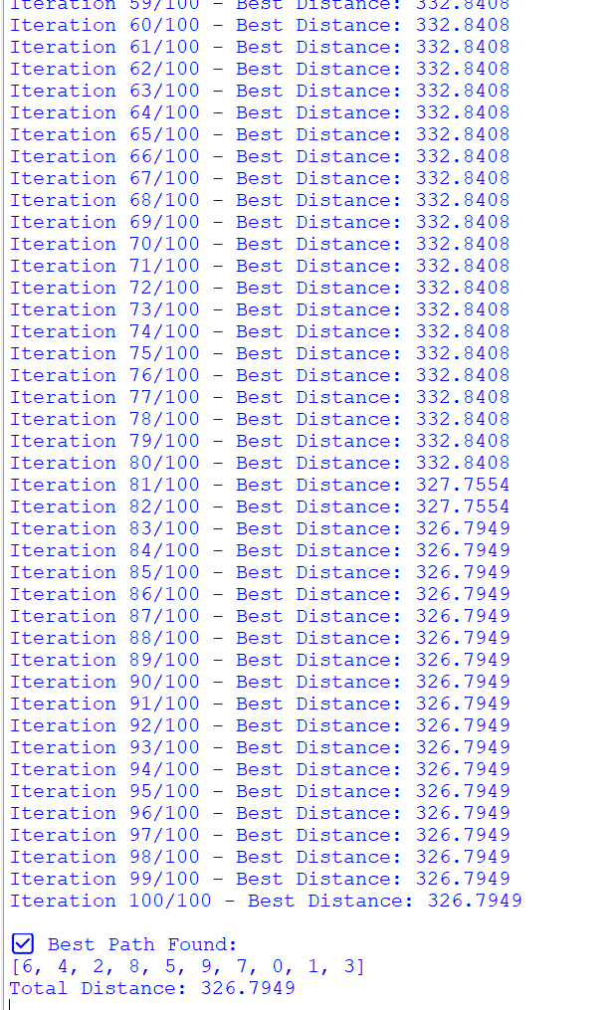

Program 6

Problem Statement:

Grey Wolf Optimizer (GWO) for Function Optimization:
Use Grey Wolf Optimization to find the best solution for a mathematical function by mimicking the hunting behavior of grey wolves.

Algorithm:
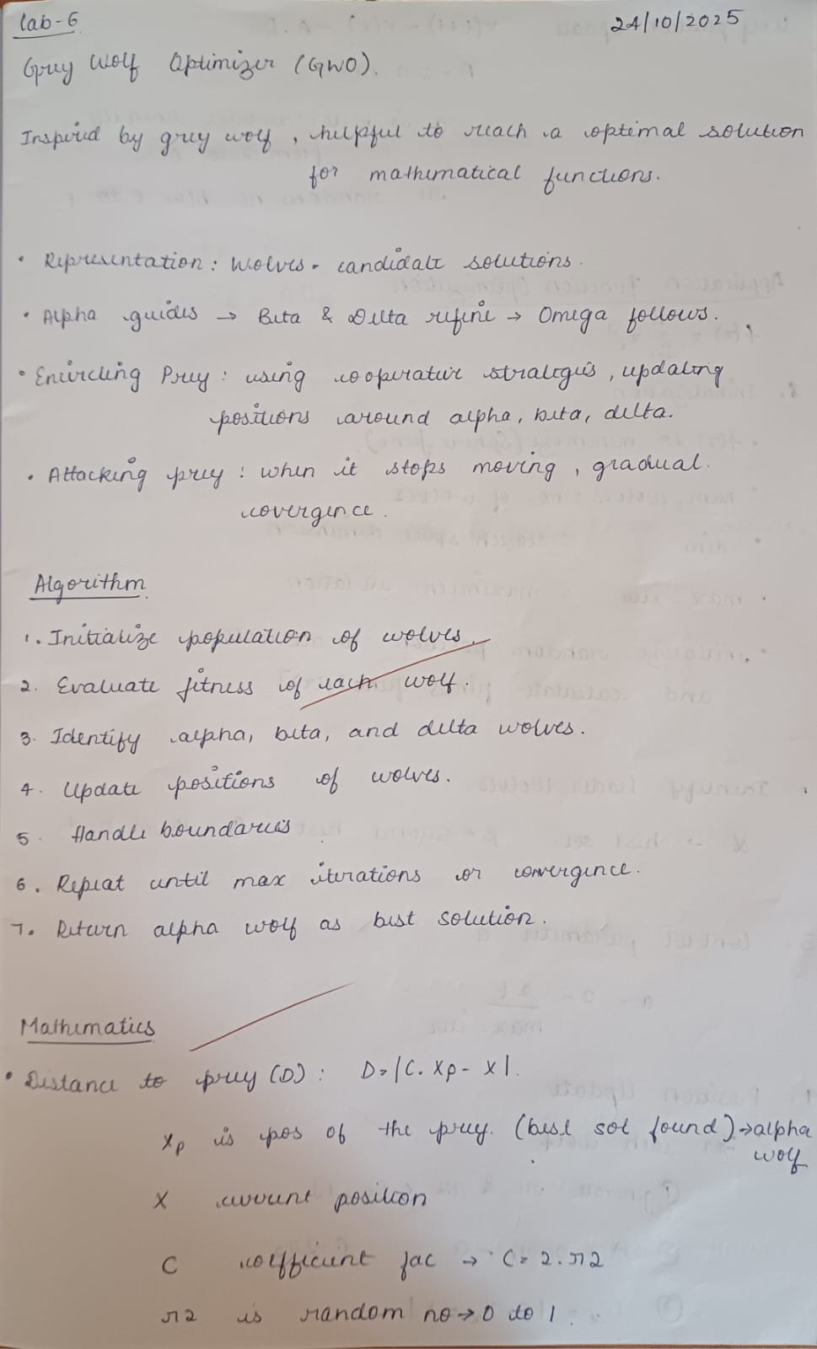
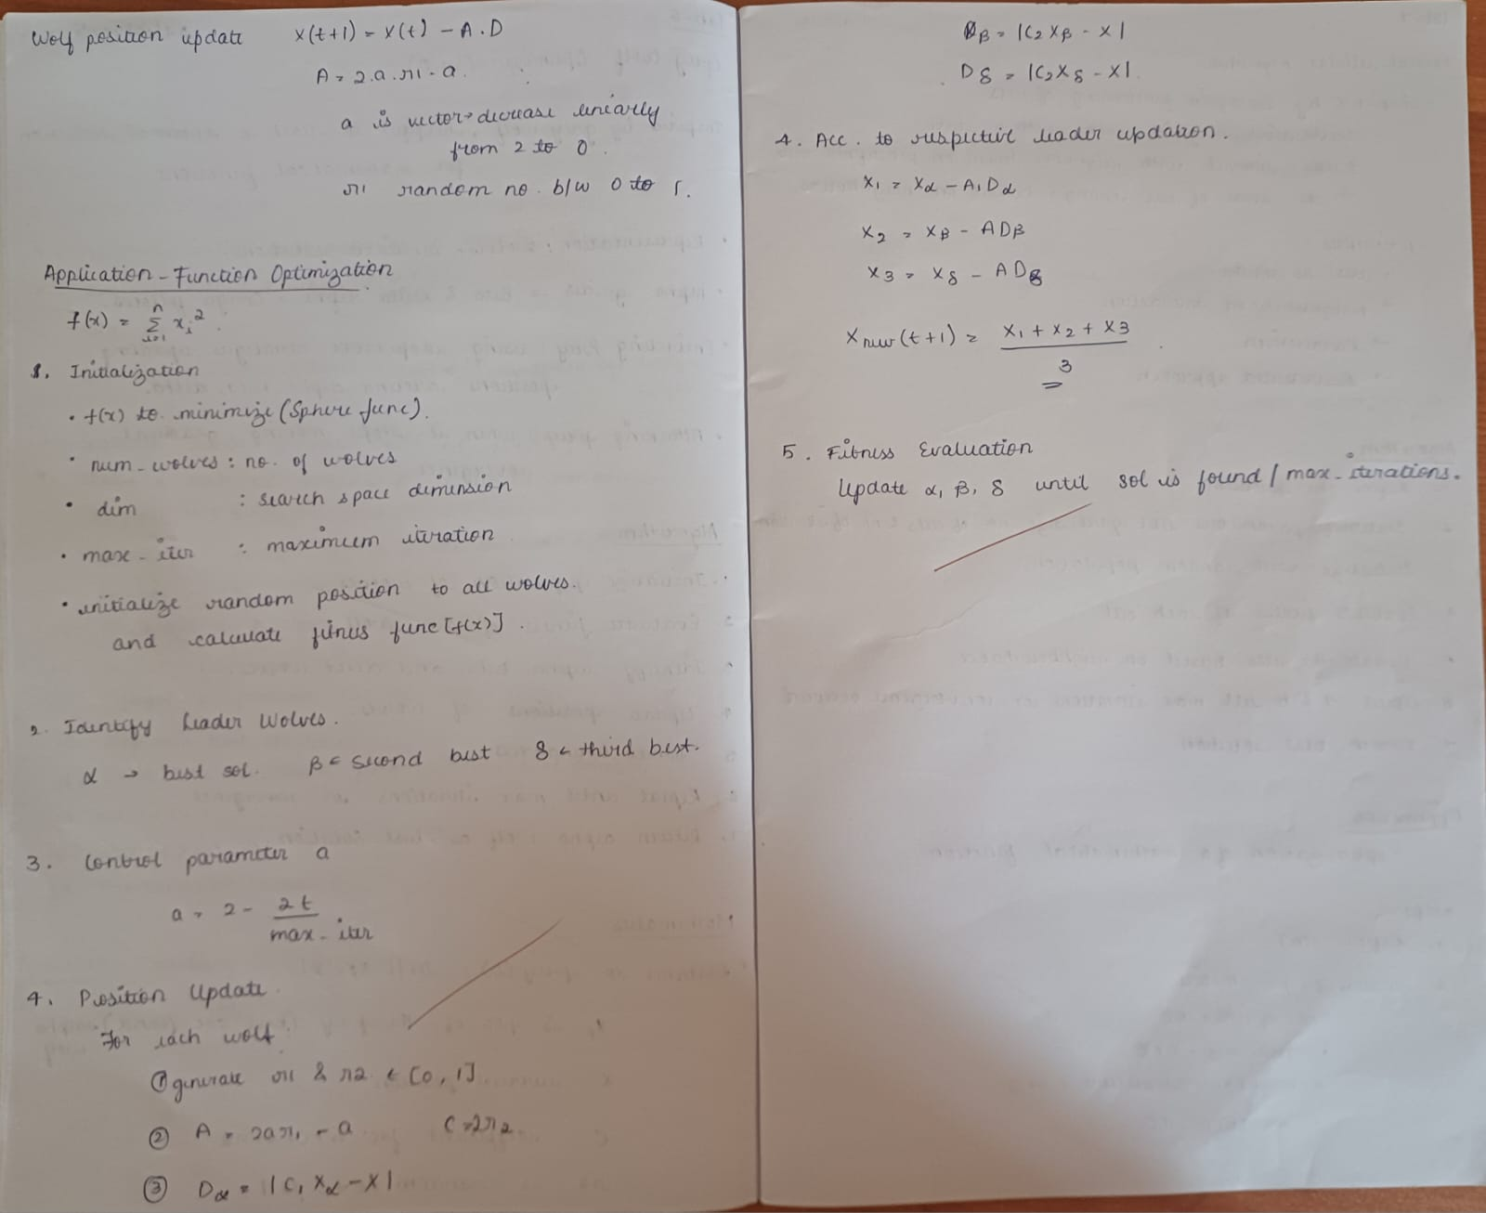

Code:
import random
import math

# -----------------------------
# Objective Function (to minimize)
# -----------------------------
def objective_function(position):
# Sphere function: sum of squares
return sum(x**2 for x in position)

# -----------------------------
# Grey Wolf Optimizer
# -----------------------------
def grey_wolf_optimizer(num_wolves=20, dim=2, max_iter=100, lower_bound=-10, upper_bound=10):
# Initialize the population of wolves randomly
wolves = [[random.uniform(lower_bound, upper_bound) for _ in range(dim)] for _ in range(num_wolves)]
fitness = [objective_function(w) for w in wolves]

# Initialize alpha, beta, delta (best 3 wolves)
alpha, beta, delta = [0]*dim, [0]*dim, [0]*dim
alpha_score, beta_score, delta_score = float("inf"), float("inf"), float("inf")

# Main loop
for t in range(max_iter):
for i in range(num_wolves):
score = fitness[i]

# Update alpha, beta, delta
if score < alpha_score:
delta_score, delta = beta_score, beta[:]
beta_score, beta = alpha_score, alpha[:]
alpha_score, alpha = score, wolves[i][:]
elif score < beta_score:
delta_score, delta = beta_score, beta[:]
beta_score, beta = score, wolves[i][:]
elif score < delta_score:
delta_score, delta = score, wolves[i][:]

# Linearly decreasing a from 2 to 0
a = 2 - t * (2 / max_iter)

# Update each wolf's position
for i in range(num_wolves):
new_position = []
for j in range(dim):
r1, r2 = random.random(), random.random()
A1 = 2 * a * r1 - a
C1 = 2 * r2
D_alpha = abs(C1 * alpha[j] - wolves[i][j])
X1 = alpha[j] - A1 * D_alpha

r1, r2 = random.random(), random.random()
A2 = 2 * a * r1 - a
C2 = 2 * r2
D_beta = abs(C2 * beta[j] - wolves[i][j])
X2 = beta[j] - A2 * D_beta

r1, r2 = random.random(), random.random()
A3 = 2 * a * r1 - a
C3 = 2 * r2
D_delta = abs(C3 * delta[j] - wolves[i][j])
X3 = delta[j] - A3 * D_delta

new_x = (X1 + X2 + X3) / 3
# Keep within bounds
new_x = max(lower_bound, min(upper_bound, new_x))
new_position.append(new_x)

wolves[i] = new_position
fitness[i] = objective_function(new_position)

print(f"Iteration {t+1}/{max_iter} - Best fitness: {alpha_score:.6f}")

return alpha, alpha_score

# -----------------------------
# Example Run
# -----------------------------
if __name__ == "__main__":
best_position, best_score = grey_wolf_optimizer(num_wolves=20, dim=5, max_iter=100)
print("\n✅ Optimization complete!")
print(f"Best position found: {best_position}")
print(f"Minimum value of function: {best_score:.6f}")

Output:
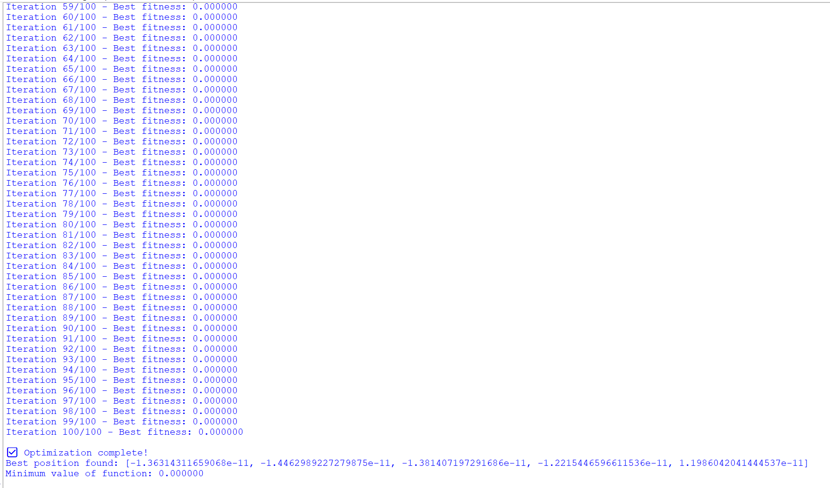

Program 7

Problem Statement:

Parallel Cellular Algorithm for Function Optimization:
Use a Parallel Cellular Algorithm to optimize a function efficiently by evolving solutions in a distributed and parallel manner.

Algorithm:
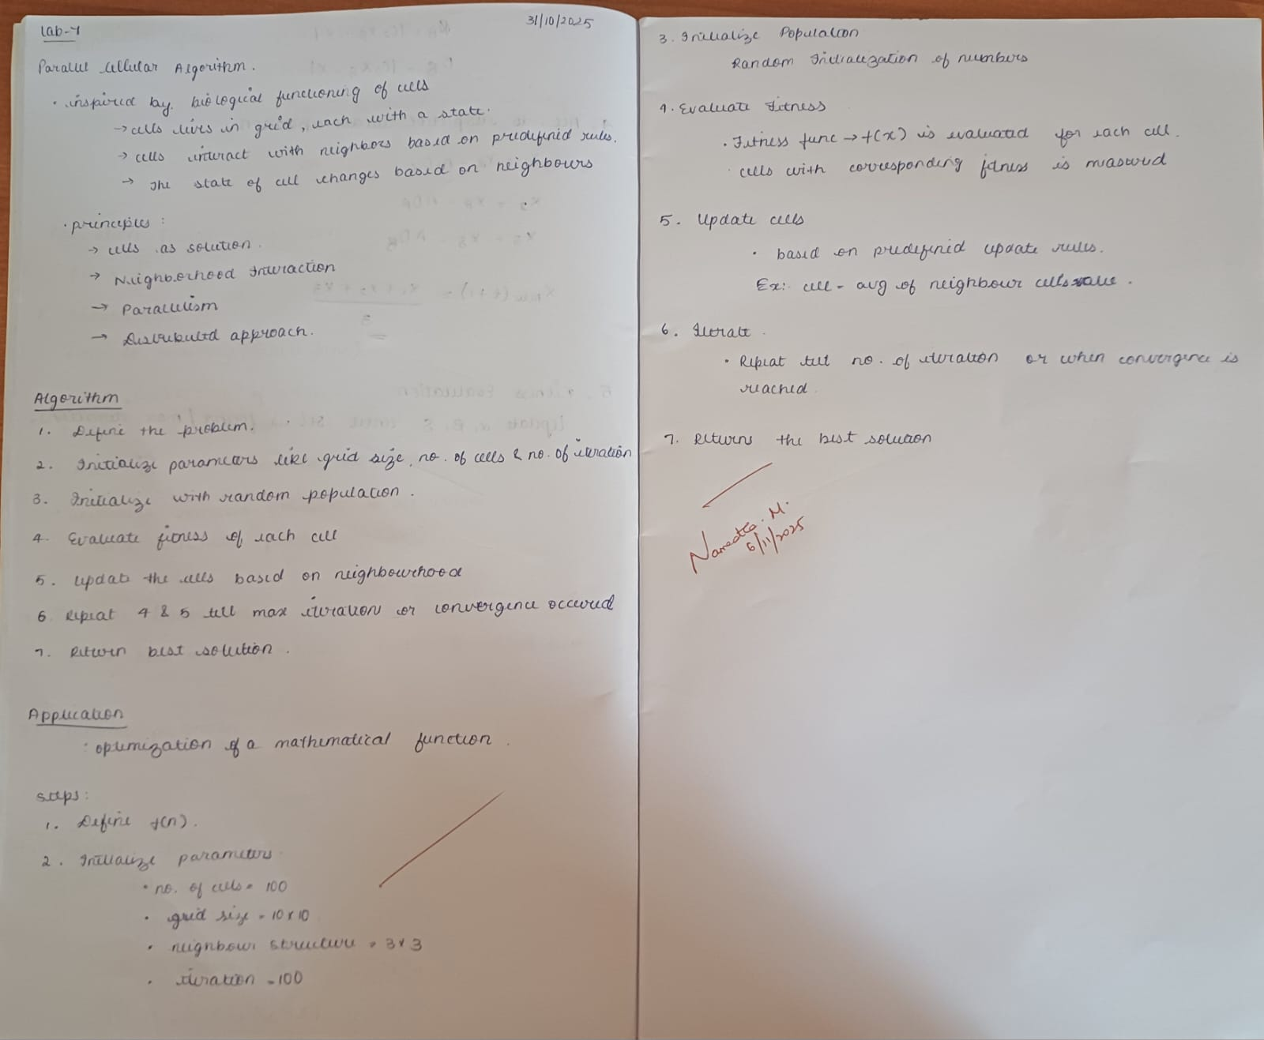

Code:
import numpy as np

def parallel_cellular_algorithm(f, grid_size=(10, 10), max_iterations=100, lb=-10, ub=10):
rows, cols = grid_size
num_cells = rows * cols

# 1. Initialize grid with random values
X = np.random.uniform(lb, ub, size=(rows, cols))

# Evaluate fitness
fitness = f(X)

# Track best global solution
best_value = np.min(fitness)
best_pos = np.unravel_index(np.argmin(fitness), fitness.shape)
best_solution = X[best_pos]

# Neighborhood offsets for 3x3 neighborhood
neighbors_offset = [(-1,-1), (-1,0), (-1,1),
(0,-1), (0,0), (0,1),
(1,-1), (1,0), (1,1)]

for iteration in range(max_iterations):
X_new = np.copy(X)

# 4. Update each cell in parallel logic
for i in range(rows):
for j in range(cols):
# Collect neighbors
neighbor_values = []
for dx, dy in neighbors_offset:
ni, nj = i + dx, j + dy
if 0 <= ni < rows and 0 <= nj < cols:
neighbor_values.append((X[ni, nj], fitness[ni, nj]))

# Get best neighbor (minimum fitness)
best_neighbor_value, _ = min(neighbor_values, key=lambda x: x[1])

# Update rule: average
X_new[i, j] = (X[i, j] + best_neighbor_value) / 2

# Boundary enforcement
X_new = np.clip(X_new, lb, ub)

# Replace old values
X = X_new

# Recalculate fitness
fitness = f(X)

# Update global best
current_best = np.min(fitness)
if current_best < best_value:
best_value = current_best
best_pos = np.unravel_index(np.argmin(fitness), fitness.shape)
best_solution = X[best_pos]

return best_solution, best_value

# -----------------------------------------------------------
# Example: Optimize Sphere Function f(x) = x^2
# -----------------------------------------------------------

def sphere_function(x):
return x**2 # works element-wise

best_x, best_val = parallel_cellular_algorithm(
f=sphere_function,
grid_size=(10, 10),
max_iterations=100,
lb=-5,
ub=5
)

print("Best solution:", best_x)
print("Best function value:", best_val)

Output:


